**A**

**PROJECT REPORT**

# ON

**LIBRARY MANAGEMENT SYSTEM**

**of Vallabh Government College Mandi (HP)**

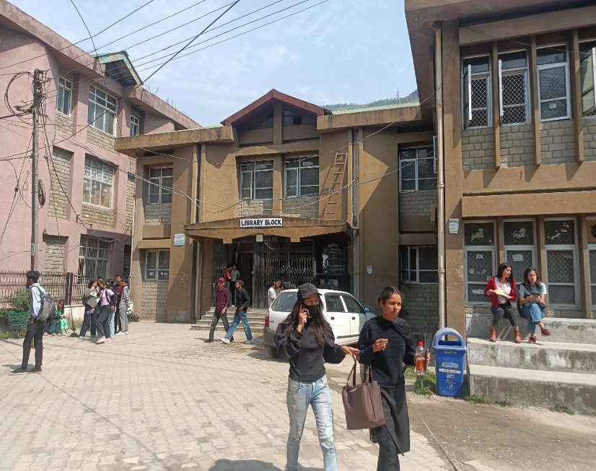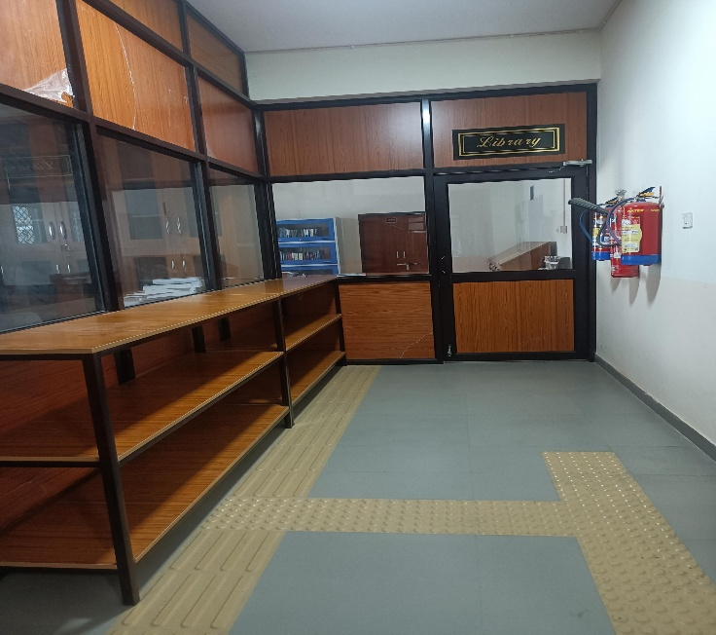

**SUBMITTED TO:**

# HIMACHAL PRADESH UNIVERSITY

**In the partial fulfilment of the requirements for the Degree of**

## BCA(Bachelor of Computer Application)

**UNDER THE SUPERVISION OF:- SUBMITTED BY:-**

**Mr. Yogesh Chaudhary**

**Mr. Vijay Thakur**  NISHANT (Uni. Roll. No. = 6200560022)

**Mrs. Vandana Kapur**

**HIMANSHI (Uni. Roll. No. = 6200560014)**



## DECLARATION

I **NISHANT** (Univ. Roll No. **6200560022**) and **HIMANSHI SHARMA** (Univ. Roll No. **6200560014**) Students of **BCA** of **VALLABH GOVERNMENT COLLEGE (MANDI)** hereby declare that the Project Report on “**LIBRARY MANAGEMENT SYSTEM**” has been prepared by us. This Project work was done under the guidance of **Mr. Yogesh Chaudhary, Mr. Vijay Thakur** and **Mrs. Vandana** **Kapur**, our Project Guide, who has helped and guided us very well.

We declare that this submitted work is done solely by us and has been successfully done in this college.

We also declare that all the information collected from various secondary sources has been duly acknowledged in this project report.

## ACKNOWLEDGEMENT

We wish to state our sense of gratitude, sincerity and acknowledge with pride the Project Work Guidance given by Our Project guide. This project report was undertaken for the fulfillment of **Library Management System.**

I would like to thanks my **College Authorities** for granting us an opportunity for such a useful project work. During the training, apart from the project work, we could also get the opportunity to have the Library Visit, get to know General Library Rules and even meeting with Librarian Madam.

We are extremely grateful to **Mr.** **Yogesh Chaudhary, Mr. Vijay Thakur, Mrs.** **Vandana** **Kapur** and **Mrs. Kavita** (Librarian), for their invaluable help and guidance throughout my work. They kindly evinced keen interest in our work and furnished some useful comments, which could enrich the work substantially.

In fact, it is very difficult to acknowledge all the names and nature of help and encouragement provided by the College Authorities. This PROJECT has given a memorable experience and has helped us in all aspects of our life.

## CERTIFICATE-I

This is certified that **NISHANT** (Univ. Roll No. **6200560022**) and **HIMANSHI SHARMA** (Univ. Roll No.

**6200560014**) Students of **BCA** has submitted their project of entitled “**Library Management** **System**”-website based on **Library Management System** of **Vallabh Government College Mandi** of **Himachal Pradesh,** Department of Bachelor of Computer Applications VGC Mandi. It is certified that project work carried out under my supervision and no part of this project work has been submitted for any other Diploma Course.

Dated..............................

Mr. Yogesh Chaudhary

Mr. Vijay Thakur

Mrs. Vandana Kapur

## CERTIFICATE-II

The Project report entitled “**Library Management System**”-website based on LibraryManagement Systemof **Vallabh Government College Mandi** of Himachal Pradeshsubmittedto **Department of** **Bachelor of Computer Applications** VGC Mandi in partial fulfilment of the requirement for the Diploma of BCA from HPU. We declare that project report entitled “Library Management System”, Vallabh Government College Mandi of Himachal Pradesh is our original work.

**Signature of Candidates:**

NISHANT

HIMANSHI SHARMA

**INTRODUCTION**

**TO**

## PROJECT

**LIBRARY MANAGEMENT SYSTEM**

of

VALLABH GOVT. COLLEGE (MANDI)

**Welcome to V.G.C (Mandi)** – An “**A**” grade college – **a premier institution**, with highly qualified academicians imparting education in different fields, the college today enjoys a reputation of outstanding performance in academics, sports and extra-curricular activities, rated among top ten Colleges of the country in Science, Computer, Commerce & Arts. The College ensures complete development of the body, mind and soul while enshrining traditional Indian values in each of its students. **The college was founded in 1948** in the sacred memory of Sardar Vallabh Bhai Patel, the first deputy Prime Minister of India, A prestigious freedom fighter of our nation. It is today one of the leading lights in Himachal Pradesh and one of the largest constituent Colleges of UNIVERSITY OF HIMACHAL PRADESH. **More than 9000 students** on its rolls interact here with a galaxy of scholars on its faculty. The college has completed **74th years** in the realm of imparting education.

**SCOPE**

**OF**

## THE

**PROJECT**

* **Project Management**
* **Content Strategy**
* **Copyright**
* **Information Design**
* **Visual Design**
* **Front-end Coding**
* **Custom Software or Web Development**
* **Testing and Quality Assurance PROJECT MANAGEMENT**

Project management is the discipline of planning, organising and managing resources for the successful completion of goals of a specific project. In simple words, it is the profession of planning, organising and managing things including people and projects. A project has a specific beginning and also has a specific end. It also has specific scope and specific resources. In other words, it is temporary. A project is not a routine business operation and has a unique set of operations that aim to accomplish one goal.

### CONTENT STRATEGY

Content Strategy is the planning, development, and management of content-written or in other media. It constitutes planning, designing, creating, editing and publishing relevant content based on the objectives and user’s needs. A content strategy helps to define goals and set priorities. A content strategy is used to plan work and ensure that all the efforts are goal driven. A documented content strategy can ensure that every bit of effort put-in translates into tangible results.

**CONTENT LIFECYCLE**

Content has a lifecycle from when it’s produced to when it’s managed and in the end, distributed throughout the user journey. The six phases of content lifecycle are project initiation and strategy development, project design and planning, execution and testing, project launch and training, evaluate and maintain, and closing.

**Stages of the content lifecycle:-**

* Project Initiation and Strategy Development

The first phase that any project goes through is the one where the team initiates the project and decide on a selected strategy. Team leader define project scope and requirements & outline the responsibilities of members. They also estimate costs based on project needs.

* Project Design and Planning

The second phase in the process is design and planning. The team then designs the entire project and decides on a detailed plan. Goals are defined & tasks are assigned to members. The team sets a detailed project schedule, with deadlines for each phase.

* Execution and Testing

The third phase includes the execution and testing phase. The team executes project components and subsequently tests them to make sure they are working properly.

* Project Launch and Training

After execution and testing if everything is working correctly, then team launches the final project & team provides relevant training on how to use the new system.

* Evaluate and Maintain

The team follow up to determine the effectiveness of your content. The maintenance stage ensures that the content remains relevant, accurate and up-to-date.

* Closing

The Project Manager can decide whether the project is closed or whether it is necessary to revise some project elements that need improvement.

### COPYRIGHTS

Copyright is the act or occupation of writing text for the purpose of advertising or other forms.

The CONTENT and DATA collected for this project is collected from our college with their permission. The college website, login page, facebook page and email pages were used as a source.

### INFORMATION DESIGN

Information design is data used as a storytelling tool. Information design is the practice of presenting information in a way that fosters an efficient and effective understanding of the information. The term has come to be used for a specific area of graphic design related to displaying information effectively, rather than just attractively or for artistic expression. Good information design helps the reader understand your data or information and digest it quickly through a clear and engaging visual. Information design is purposeful and helps people understand complex ideas, a subjective opinion, complete a task, or solve a problem.

### VISUAL DESIGN

Visual design focuses on the aesthetics of a site and its related materials by strategically implementing images, colours, fonts and other elements. A successful visual design does not take away from the content on the page or function. It aims to shape and improve the user experience through considering the effects of illustrations, photography, typography, space, layouts and colour on the usability of products. Visual design as a field has grown out of both User Interface (UI) and Graphic Design.

User Interface (UI) Design focuses on anticipating what users might need not to do and ensuring that the interface has elements that are easy to access, understand and use to facilitate those actions, UI brings together concepts from interaction design, visual design and information architecture.

Graphic Design is a profession, academic discipline and applied art whose activity consists in projecting visual communications intended to transmit specific messages to social groups, with specific objectives. Graphic design is an interdisciplinary branch of design and of the fine arts.

### FRONT-END CODING

**THE BASICS OF FRONT-END TOOLS & TECHNOLOGY**

Back in the day, websites were simple, static text sites with a bit of formatting and with some animation. That was all thanks to HTML and CSS.

It’s important to note that front-end development has changed significantly over the past

15 to 20 years with explosive growth of JavaScript, which wasn’t as ubiquitous on the front end as it is now, or even as common on the back end, thanks to Node.js.It enable you to interact with the web and its actions.

**Some of the core technologies used in front-end development include:**

**HTML: The Organizer**

Hyper Text Markup Language (HTML) is the standard markup language for documents designed to be displayed in a web browser and it also describe the structure of a web page. It allows the creation and structure of sections, paragraphs and links using HTML elements (the building blocks of a web page) such as tags and attributes.

**CSS: The Stylist**

Cascading Style Sheets (CSS) is a computer language for laying out and structuring web pages (HTML or XML). This language contains coding elements and is composed of these “cascading style sheets” which are equally called CSS files. With CSS, you can control the colour, font, the size of text, the spacing between elements, how elements are positioned and laid out, what background images or background colours are to be used.

**JAVASCRIPT**

JavaScript (JS) is a lightweight, interpreted, or just-in-time compiled programming language with first-class functions. While it is well-known as the scripting language for Web Pages, many non-browser environments also use it, such as Node.js, Apache CouchDB and Adobe Acrobat.

### CUSTOM SOFTWARE OR WEB DEVELOPMENT

Customised Software (also known as bespoke software or tailor-made software) is software that is specially developed for some specific organization or other user. As such it can be contrasted with the use of software packages developed for the mass market, such as commercial off-the-shelf software, or existing free software.

Since custom software is developed for a single customer it can accommodate that customer’s particular preferences and expectations, which may not be the case for commercial off-the-shelf software. Custom software may be developed in an iterative processes, allowing all nuances and possible hidden risks to be taken into account, including issues which were not mentioned in the original requirement specifications(which are, as a rule, never perfect). In particular, the first phase in the software development process may involve many departments, including marketing, engineering, research and development and general management.

**TESTING QUALITY AND ASSURANCE**

**Quality Assurance Testing**

Testing is the process used to execute a system of quality assurance. It is used to detect the problems in a product or service. The importance of testing is obvious: the product or service that is completed improperly is going to dissatisfy the stakeholder, but there can also be safety issues that will put people in harm’s way if not addressed.

Testing requires the following:

* Analysis and definition
* Design architecture and description
* Coding a logic analysis
* Change and configuration management
* Testing and standard compliance
* Release management and release control

The difference between quality assurance and testing is that quality assurance is about the activities designed to make sure the project is confirming to the expectations of the stakeholders, while test is a process to explore a system to find defects. Testing’s aim is to control the quality, while quality assurance is to assure the quality.

**ACTUAL**

**PROJECT**

**WORK**

**What is Library Management System?**

An Integrated Library System (ILS), also known as a Library Management System (LMS), is an enterprise resource planning system for a library, used to track items owned, orders made, bills paid, and patrons who have borrowed.

An ILS usually is constituted of a relational database, software to interact with that database, software to interact with that database, and two graphical user interfaces (one for patrons, one for staff). Most ILSes separate software functions into discrete programs called modules, each of them integrated with a unified interface

**Elements of LIBRARY MANAGEMENT SYSTEM**

* Cataloguing
* Membership
* Report
* Status
* Report Generator
* Online Public Access Catalogue
* Acquisition

### SCOPE OF LIBRARY MANAGEMENT SYSTEM

A library management software automates all tasks involved in a library, from book purchasing to stock checking. It eliminates the need for human intervention and reduces errors.Managing a library is surely not an easy task. The librarians will have to keep track of thousands of books without fail. A library management system software helps you to do the task with ease. The software can easily store and manage all the details of every book in the library without errors. Moreover, anyone can find the book they want in a matter of seconds. Thus, good library management system software not only helps college but also allows students to find the required book in time.

* **BETTER EFFICIENCY**

Library management software can improve the overall efficiency of a college in many ways.

* **TIME-SAVING**

Managing library activities manually is a time-consuming process. A good library management system can solve these issues.

* **COST-EFFECTIVE**

Library management software can save your money in different ways. Moreover, college can eliminate the use of paper-based procedures and reduce expenses.

* **BETTER SECURITY**

Online library management software is a way more secure than paper-based procedures.

* **INCREASED ENGAGEMENT**

More engagement can be seen in the library since all the books are available at the fingertips of students.

* **EASY ACCESS**

Librarians can access all the library data from anywhere using their smartphones or computers. Students can also access library facilities with ease during their smartphones.

* **ERROR-FREE**

An online library management system is entirely error-free since it is automated.

* **CUSTOMIZABLE**

The procedure to borrow and return books may also be different. Library management system is easily customizable. It means you can set up the system according to your needs.

### DEVELOPMENT OF LIBRARY MANAGEMENT SYSTEM

The market is bustling with a number of library management system solutions, but still, the customers are in search of the one that suits their expectations. The majority of the population that uses the library are students and researchers. When dealing with students, always think of an innovative way to introduce your software that impresses them.

The development process can be divided into three major parts, which are market analysis, laying out the plan and execution (including testing).

* **MARKET ANALYSIS**

The development of a library management system can be a complex task given that it consists of numerous features, simple design, and much more. The students of this genre is not interested in wasting any time, they want instant solutions, and hence, the software should be able to satisfy their every query or any need.

* **LAYING OUT THE PLAN**

With in-depth market analysis, your team would have a set of intelligent insights to proceed further with the development of a Library managing system solution.

* **EXECUTION**

The team executes project components and subsequently tests them to make sure they are working properly.

Front-end developers don’t usually create mock-ups, select typography, or pick colour palettes—these are usually provided by the designer. It’s the developer’s job to bring those mock-ups to life.

## HTML

**(Hyper Text Markup Language)**

Hyper Text Markup Language (HTML) is the standard markup language for documents designed to be displayed in a web browser and it also describe the structure of a web page. It allows the creation and structure of sections, paragraphs and links using HTML elements (the building blocks of a web page) such as tags and attributes.

## CSS

**(Cascading Style Sheet)**

Cascading Style Sheets (CSS) is a computer language for laying out and structuring web pages (HTML or XML). This language contains coding elements and is composed of these “cascading style sheets” which are equally called CSS files.

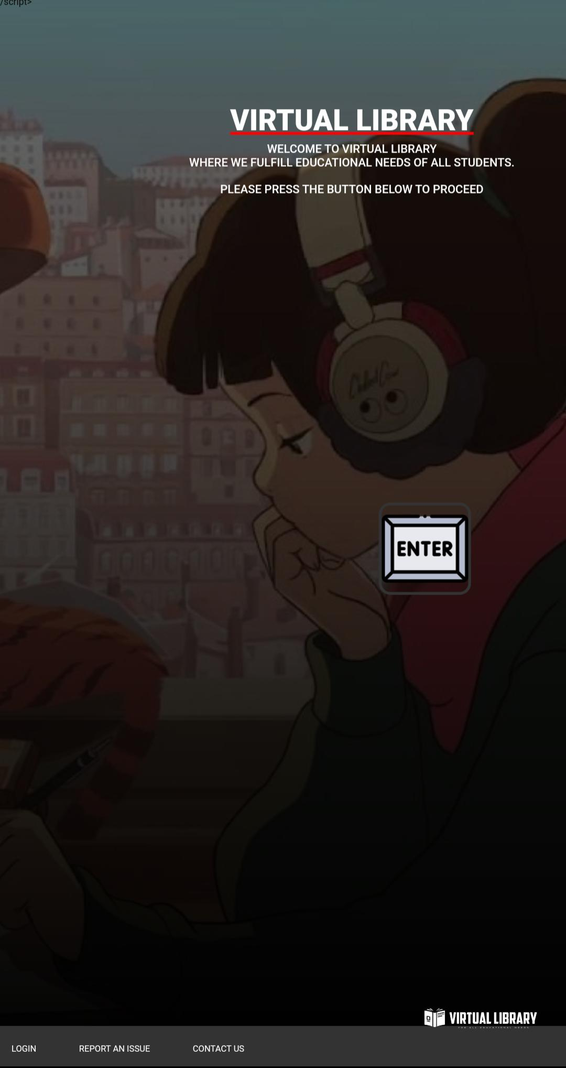**The final output of the project :** 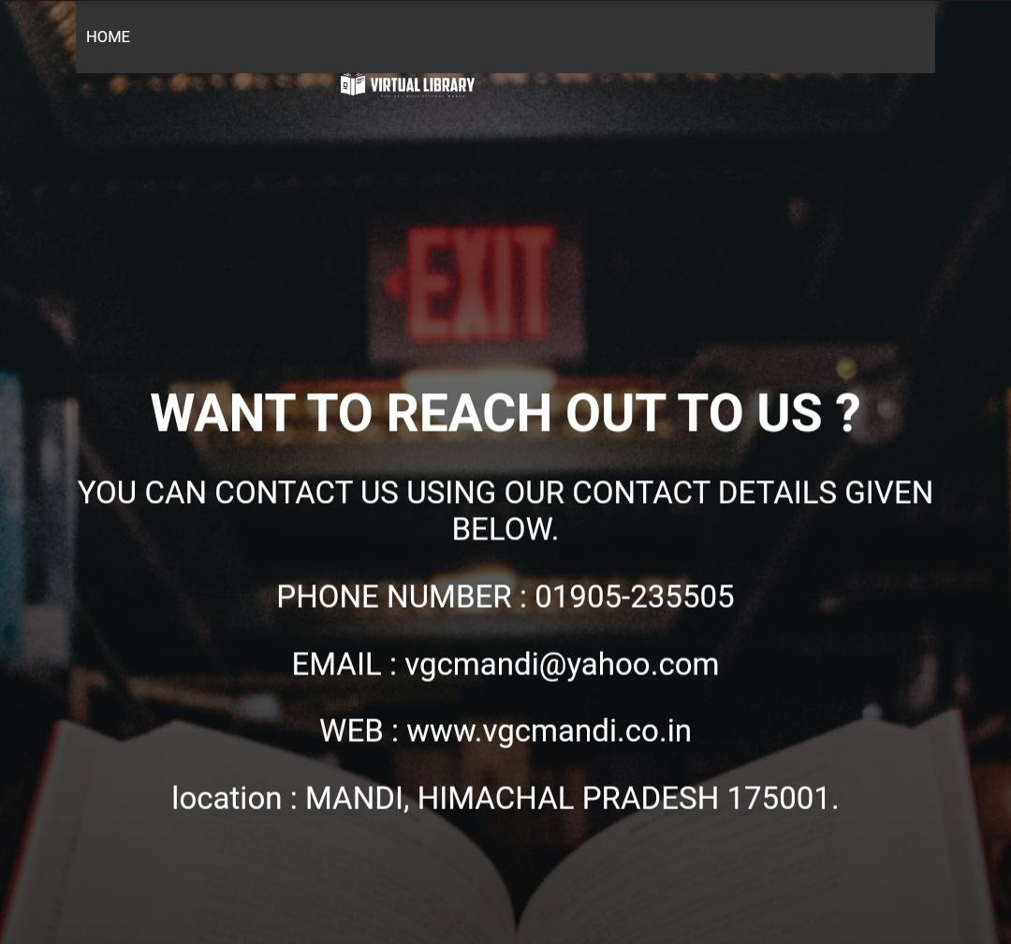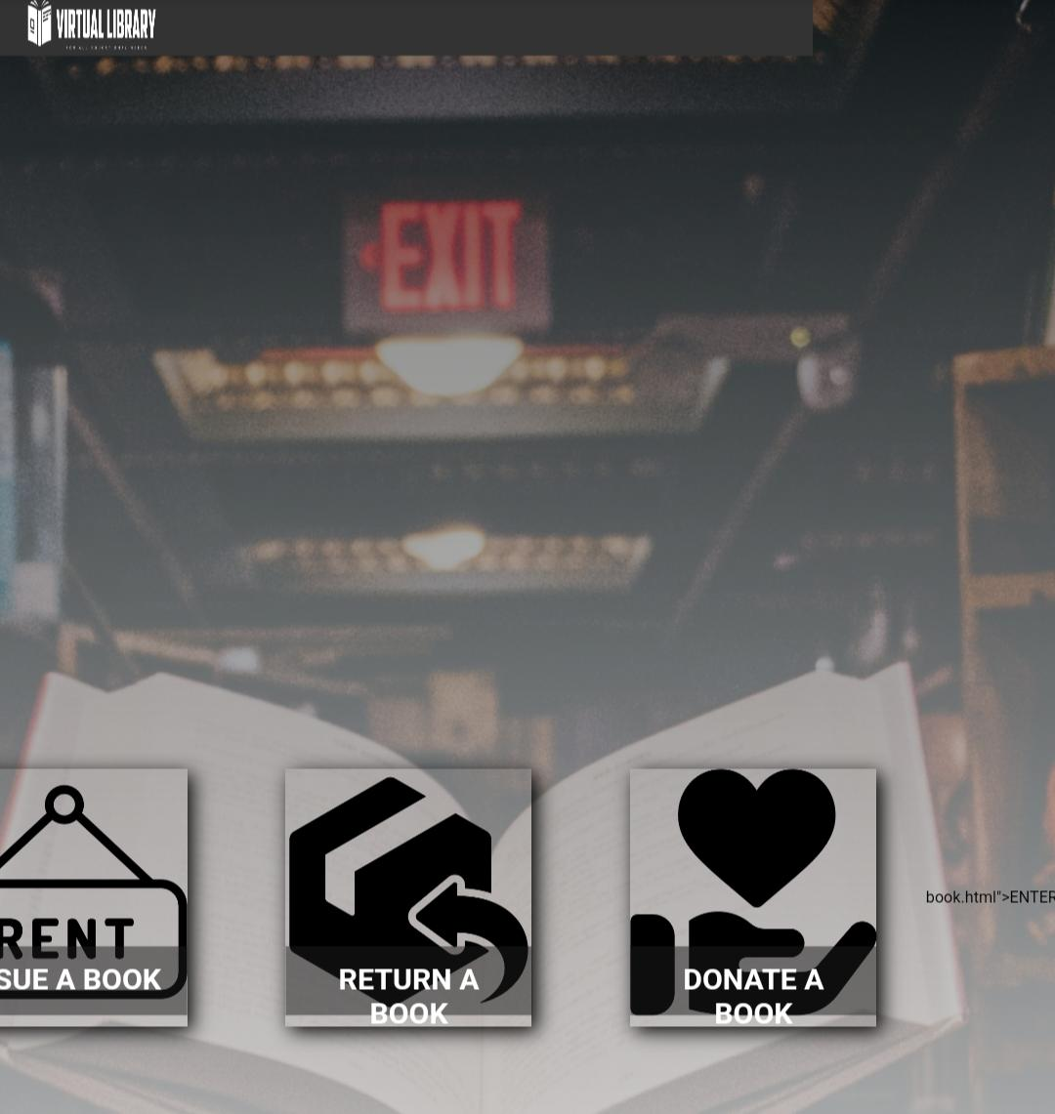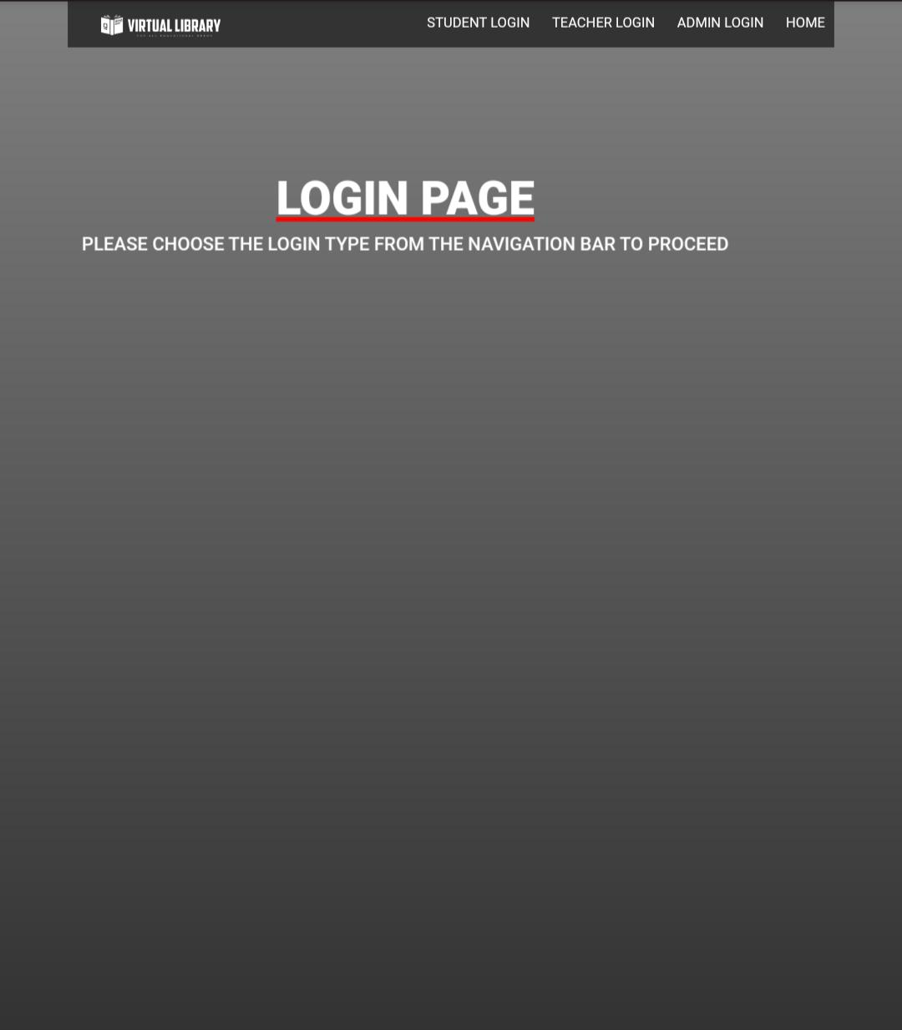

### 

<!DOCTYPE HTML>

<html>

<head>

<link rel=”stylesheet” href=”style.css”>

</head>

<body>

<section id=”banner”>

<div class=”bannertext”>

<h1>VIRTUAL LIBRARY</h1>

<p>WELCOME TO VIRTUAL LIBRARY<br> WHERE WE FULFILL EDUCATIONAL NEEDS OF ALL STUDENTS.<br><br>PLEASE PRESS THE BUTTON BELOW TO PROCEED</p>

</div>

</section>

<div id=”bnav”>

<img src=”librarylogo.png” class=”logo”>

<nav>

<ul>

<li><a href=”chooselogin.html”>LOGIN</a></li>

<!-- <li><a href=”counter.html”>BOOKS</a></li>🡪

<li><a href=”report an issue.html”>REPORT AN ISSUE</a></li>

<li><a href=”contact.html”>CONTACT US</a></li>

</ul>

</nav>

</div>

<div id=”btn”>

<img src=”enter.png” id=”menu”>

</div>

<script>

Var btn = document.getElementById(“btn”)

Var bnav = document.getElementById(“bnav”)

Var menu = document.getElementById(“menu”)

Btn.onclick = function(){

If(bnav.style.bottom == “-250px”){

Bnav.style.bottom = “0”;

}

Else{

Bnav.style.bottom = “-250px”;

}

}

</script>

</body>

</html> /script>

</body>

</html>

*{

Margin: 0;

Padding: 0;

}

Body{

Background: linear-gradient(rgba(0,0,0,0.5),#000000),url(bg.jpg);

Background-size: cover;

Background-position: center;

Height: 100vh;

Width: 100%;

}

.logo{

Width: 300px;

Position: absolute;

Bottom: 0;

Right: 0;

}

.bannertext{

Top: 10%;

Right: 5%;

Position: absolute;

Text-align: center;

Color: #fff;

Background: transparent;

Backdrop-filter:blur(2px);

}

.bannertext h1{

Margin-bottom: 5px;

Font-size: 50px;

Position: relative;

Font-weight: 900;

Text-decoration: underline;

Text-decoration-color: red;

}

.bannertext p{

Font-weight: 500;

Margin-top: 9px;

Font-size: 20px;

Padding-left: 40px;

Padding-right: 40px;

}

#bnav{

Width: 100%;

Height: 70px;

Position: fixed;

Right: 0;

Bottom: -250px;

Background: #333;

z-index: 2;

transition: 0.3s;

}

#btn{

Width: 50px;

Height: 50px;

Background: transparent;

Text-align: center;

Position: fixed;

Right: 28%;

Bottom: 50%;

Border-radius: 3px;

z-index: 3;

cursor: pointer;

}

#btn img{

Width: 150px;

/* margin-bottom: 15px;*/

Border: 5px solid #333;

Border-radius: 20px;

Backdrop-filter:blur(5px);

}

Nav ul li{

Display: inline-block;

Margin: 30px 20px;

Margin-right: 50px;

}

Nav ul li a{

Font-size: 15px;

Text-decoration: none;

Color: #fff;

}

Nav ul li a:hover{

Background: #fff;

Color: #000;

}

<html>

<head>

<link rel=”stylesheet” href=”chooselogin.css”>

</head>

<body>

<div class=”navbar”>

<img src=”librarylogo.png” class=”logo”>

<ul>

<li><a href=”enter.html”>STUDENT LOGIN</a></li>

<li><a href=”teacher.html”>TEACHER LOGIN</a></li>

<li><a href=”admin.html”>ADMIN LOGIN</a></li>

<li><a href=”projectnerd.html”>HOME</a></li>

</ul>

</div>

<section id=”banner”>

<div class=”bannertext”>

<h1>LOGIN PAGE</h1>

<p>PLEASE CHOOSE THE LOGIN TYPE FROM THE NAVIGATION BAR TO PROCEED</p>

</div>

</section>

</body>

</html>

*{

Margin: 0;

Padding: 0;

Box-sizing: border-box;

Font-family: sans-serif;

}

Body{

Width: 100%;

Height: 100vh;

Display: flex;

Justify-content: center;

Align-items: center;

Background: linear-gradient(rgba(0,0,0,0.5),#000000);

Background-size: cover;

Background-position: center;

}

.navbar{

Background-color: #333;

Height: 50px;

Overflow: hidden;

Width: 85%;

Margin-bottom: auto;

Padding: 10px 0;

Display: flex;

Align-items: center;

Justify-content:space-between;

}

.logo{

Width: 200px;

Cursor: pointer;

}

.navbar ul li{

List-style: none;

Display:inline-block;

Margin: 0 10px;

Position: relative;

}

.navbar ul li a{

Float: left;

Font-size: 15px;

Color: #fff;

Text-transform: uppercase;

Text-decoration: none;

}

.navbar ul li::after{

Content: ‘’;

Height: 3px;

Width: 0;

Background: red;

Position: absolute;

Left: 0;

Bottom: -10px;

Transition: 0.3s;

}

.navbar ul li:hover::after{

Width: 100%;

}

.navbar ul li a.active{

Background-color: white;

Color: #000;

}

.bannertext{

Top: 10%;

Left: 5%;

Position: absolute;

Text-align: center;

Color: #fff;

Background: transparent;

Backdrop-filter:blur(2px);

}

.bannertext h1{

Margin-bottom: 5px;

Font-size: 50px;

Position: relative;

Font-weight: 900;

Text-decoration: underline;

Text-decoration-color: red;

}

.bannertext p{

Font-weight: 500;

Margin-top: 9px;

Font-size: 20px;

Padding-left: 40px;

Padding-right: 40px;

}right: 40px;

}

<!DOCTYPE HTML>

<html>

<head>

<link rel=”stylesheet” href=”enter.css”>

</head>

<body>

<div class=”navbar”>

<img src=”librarylogo.png” class=”logo”>

<ul>

<li><a class=”active” href=”enter.html”>STUDENT LOGIN</a></li>

<li><a href=”teacher.html”>TEACHER LOGIN</a></li>

<li><a href=”admin.html”>ADMIN LOGIN</a></li>

<li><a href=”projectnerd.html”>HOME</a></li>

</ul>

</div>

<div class=”wrapper”>

<div class=”form box login”>

<h2>STUDENT LOGIN</h2>

<form action=”counter.html” method=”post”>

<div class=”input-box”>

<span class=”icon”></span>

<input type=”email” required>

<label> EMAIL</label>

</div>

<div class=”input-box”>

<span class=”icon”></span>

<input type=”PASSWORD” required>

<label> PASSWORD</label>

</div>

<div class=”remember-forgot”>

<label><input type=”checkbox”>REMEMBER ME</label>

<a href=”#”>forgot password?</a>

</div>

<button type=”submit” class=”btn”>LOGIN</button>

<div class=”login-register”>

<p>DON’T HAVE AN ACCOUNT ?<a href=”register.html” class=”register-link”>REGISTER</a></p>

</div>

</form>

</div>

</div>

</body>

</html>

*{

Margin: 0;

Padding: 0;

Font-family: montserrat;

}

Body{

Display: flex;

Justify-content: center;

Align-items: center;

Background: linear-gradient(rgba(0,0,0,0.5),#000000),url(swing.jpg);

Background-size: cover;

Background-position: center;

Height: 100vh;

Width: 100%;

Text-align: center;

}

.wrapper{

Position: absolute;

Width: 400px;

Height: 440px;

Background: transparent;

Border: 2px solid rgba(255,255,255,.5);

Border-radius: 20px;

Backdrop-filter: blur(1px);

Color: #fff;

Display: flex;

Justify-content: center;

Align-items: center;

}

.wrapper .form-box{

Width: 100%;

Padding: 40px;

}

.form-box h2{

Font-weight: 900;

Font-size: 2em;

Color: #fff;

Text-align: center;

}

.input-box{

Position: relative;

Width: 100%;

Height: 50px;

Border-bottom: 2px solid #fff;

Margin: 30px 0;

}

.input-box label{

Position: absolute;

Top: 50%;

Left: 5px;

Transform: translateY(-50%);

Font-size: 1em;

Color: #fff;

Font-weight: 900;

Pointer-events: none;

Transition: .5s;

}

.input-box input:focus~label,

.input-box input:valid~label {

Top: -5px;

}

.input-box input{

Width: 100%;

Height: 100%;

Background: transparent;

Border: none;

Outline: none;

Color: #fff;

Font-size: 1em;

Font-weight: 600;

Padding: 0 35px 0 5px;

}

.input-box .icon{

Position: absolute;

Right: 8px;

Font-size: 1.2em;

Color: #fff;

Line-height: 57px;

}

.remember-forgot{

Font-size: 17px;

Color: #fff;

Font-weight: 500;

Margin: -15px 0 15px;

Display: flex;

Justify-content: space-between;

}

.remember-forgot label input{

Font-weight: 500;

Accent-color: #fff;

Margin-right: 3px;

}

.remember-forgot a{

Padding-left: 25px;

Color: #fff;

Text-decoration: none;

Font-size: 19px;

}

.remember-forgot a:hover{

Text-decoration: underline;

}

.btn{

Width: 100%;

Height: 45px;

Background: transparent;

Border: none;

Outline: none;

Border-radius: 6px;

Cursor:pointer;

Font-size: 1em;

Color: #fff;

Font-weight: 500;

Border: 2px solid red;

}

.login-register{

Font-size: .9em;

Color: #fff;

Text-align: center;

Font-weight: 500;

Margin: 25px 0 10px;

}

.login-register p a{

Padding-left: 25px;

Color: #fff;

Text-decoration: none;

Font-weight: 600;

Font-size: 19px;

}

.login-register p a:hover{

Text-decoration: underline;

Text-decoration-color: red;

Text-decoration-style: solid;

}

.navbar{

Background-color: #333;

Height: 30px;

Overflow: hidden;

Width: 85%;

Margin-bottom: auto;

Padding: 10px 0;

Display: flex;

Align-items: center;

Justify-content:space-between;

}

.logo{

Width: 200px;

Cursor: pointer;

}

.navbar ul li{

List-style: none;

Display:inline-block;

Margin: 0 10px;

Position: relative;

}

.navbar ul li a{

Float: left;

Font-size: 15px;

Color: #fff;

Text-transform: uppercase;

Text-decoration: none;

}

.navbar ul li::after{

Content: ‘’;

Height: 3px;

Width: 0;

Background: red;

Position: absolute;

Left: 0;

Bottom: -10px;

Transition: 0.3s;

}

.navbar ul li:hover::after{

Width: 100%;

}

.navbar ul li a.active{

Background-color: white;

Color: #000;

}

<!DOCTYPE HTML>

<html>

<head>

<link rel=”stylesheet” href=”register.css”>

</head>

<body>

<div class=”navbar”>

<img src=”librarylogo.png” class=”logo”>

<ul>

<li><a href=”projectnerd.html”>HOME</a></li>

</ul>

</div>

<div class=”wrapper”>

<div class=”form box login”>

<h2>REGISTER HERE</h2><hr>

<form action=”counter.html” method=”post”>

<div class=”input-box”>

<span class=”icon”></span>

<input type=”email” required>

<label> EMAIL</label>

</div>

<div class=”input-box”>

<span class=”icon”></span>

<input type=”PASSWORD” required>

<label> PASSWORD</label>

</div>

<div class=”input-box”>

<span class=”icon”></span>

<input type=”text” required>

<label>NAME</label>

</div>

<div class=”input-box”>

<span class=”icon”></span>

<input type=”date” required>

</div>

<button type=”submit” class=”btn”>CREATE ACCOUNT</button>

</form>

</div>

</div>

</body>

</html>OGIN</a></p>

</div>

</form>

</div>

</div>

</body>

</html>

*{

Margin: 0;

Padding: 0;

Font-family: montserrat;

}

Body{

Display: flex;

Justify-content: center;

Align-items: center;

Background: linear-gradient(rgba(0,0,0,0.5),#000000);

Background-size: cover;

Background-position: center;

Height: 100vh;

Width: 100%;

Text-align: center;

}

.wrapper{

Position: absolute;

Width: 400px;

Height: 440px;

Background: transparent;

Border: 2px solid rgba(255,255,255,.5);

Border-radius: 20px;

Backdrop-filter: blur(1px);

Color: #fff;

Display: flex;

Justify-content: center;

Align-items: center;

}

.wrapper .form-box{

Width: 100%;

Padding: 40px;

}

.form-box h2{

Font-weight: 900;

Font-size: 19PX;

Color:red;

Text-align: center;

}

.input-box{

Position: relative;

Width: 100%;

Height: 50px;

Border-bottom: 2px solid #fff;

Margin: 30px 0;

}

.input-box label{

Position: absolute;

Top: 50%;

Left: 5px;

Transform: translateY(-50%);

Font-size: 1em;

Color: #fff;

Font-weight: 900;

Pointer-events: none;

Transition: .5s;

}

.input-box input:focus~label,

.input-box input:valid~label {

Top: -5px;

}

.input-box input{

Width: 100%;

Height: 100%;

Background: transparent;

Border: none;

Outline: none;

Color: #fff;

Font-size: 1em;

Font-weight: 600;

Padding: 0 35px 0 5px;

}

.input-box .icon{

Position: absolute;

Right: 8px;

Font-size: 1.2em;

Color: #fff;

Line-height: 57px;

}

.remember-forgot{

Font-size: 17px;

Color: #fff;

Font-weight: 500;

Margin: -15px 0 15px;

Display: flex;

Justify-content: space-between;

}

.remember-forgot label input{

Font-weight: 500;

Accent-color: #fff;

Margin-right: 3px;

}

.remember-forgot a{

Padding-left: 25px;

Color: #fff;

Text-decoration: none;

Font-size: 19px;

}

.remember-forgot a:hover{

Text-decoration: underline;

}

.btn{

Width: 100%;

Height: 45px;

Background: transparent;

Border: none;

Outline: none;

Border-radius: 6px;

Cursor:pointer;

Font-size: 1em;

Color: #fff;

Font-weight: 500;

Border: 2px solid red;

}

.login-register{

Font-size: .9em;

Color: #fff;

Text-align: center;

Font-weight: 500;

Margin: 25px 0 10px;

}

.login-register p a{

Padding-left: 25px;

Color: #fff;

Text-decoration: none;

Font-weight: 600;

Font-size: 19px;

}

.login-register p a:hover{

Text-decoration: underline;

Text-decoration-color: red;

Text-decoration-style: solid;

}

.navbar{

Background-color: #333;

Height: 30px;

Overflow: hidden;

Width: 85%;

Margin-bottom: auto;

Padding: 10px 0;

Display: flex;

Align-items: center;

Justify-content:space-between;

}

.logo{

Width: 200px;

Cursor: pointer;

}

.navbar ul li{

List-style: none;

Display:inline-block;

Margin: 0 10px;

Position: relative;

}

.navbar ul li a{

Float: left;

Font-size: 15px;

Color: #fff;

Text-transform: uppercase;

Text-decoration: none;

}

.navbar ul li::after{

Content: ‘’;

Height: 3px;

Width: 0;

Background: red;

Position: absolute;

Left: 0;

Bottom: -10px;

Transition: 0.3s;

}

.navbar ul li:hover::after{

Width: 100%;

}

.navbar ul li a.active{

Background-color: white;

Color: #000;

}

<html>

<head>

<link rel=”stylesheet” href=”counter.css”>

</head>

<body>

<div class=”navbar”>

<img src=”librarylogo.png” class=”logo”>

<ul>

<li><a href=”chooselogin.html”>LOGIN PAGE</a></li>

<li><a href=”projectnerd.html”>HOME</a></li>

</ul>

</div>

<div class=”container”>

<div class=”card”>

<img src=”rent.png” alt=”issue”>

<div class=”intro”>

<h1>ISSUE A BOOK</h1>

<p>STUDENTS CAN ISSUE BOOKS ACCORDING TO THEIR NEEDS.</p>

<a href=”rentbook.html”>ENTER</a>

</div>

</div>

</div>

<div class=”container”>

<div class=”card”>

<img src=”return-box.png” alt=”return”>

<div class=”intro”>

<h1>RETURN A BOOK</h1>

<p>RETURN AN PREVIOUSLY ISSUED BOOKS FROM THE LIBRARY.</p>

<a href=”returnbook.html”>ENTER</a>

</div>

</div>

</div>

<div class=”container”>

<div class=”card”>

<img src=”heart.png” alt=”donate”>

<div class=”intro”>

<h1>DONATE A BOOK</h1>

<p>DONATING BOOK IS HGHLY APPRICIATED.EVERY BOOK DONATED WILL BE HELPFUL TO THE STUDENTS.</p>

<a href=”donate.html”>ENTER</a>

</div>

</div>

</div>

<!—

<div class=”container”>

<div class=”card”>

<img src=”job-description.png” alt=”form”>

<div class=”intro”>

<h1>LIBRARY CARD</h1>

<p>STUDENTS MUST APPLY FOR LIBRARY CARD TO USE THE COLLEGE LIBRARY SERVICES.</p>

<a href=”rentbook.html”>ENTER</a>

</div>

</div>

</div>

🡪

</body>

</html>book.html”>ENTER</a>

</div>

</div>

</div>

</body>

</html>

*{

Margin: 0;

Padding: 0;

}

Body{

Background: linear-gradient(rgba(0,0,0,0.5),#fff),url(“wingardium.jpg”);

Background-position: center;

Background-size: cover;

Width: 100%;

Height: 100vh;

Display: flex;

Justify-content: center;

Align-items:center;

Overflow: hidden;

}

.navbar{

Background-color: #333;

Height: 50px;

Width: 85%;

Margin-bottom: auto;

Padding: 10px 0;

Display: flex;

Top: 0;

Left: 0;

Align-items: center;

Justify-content:space-between;

Position: absolute;

}

.logo{

Width: 200px;

Cursor: pointer;

}

.navbar ul li{

List-style: none;

Display:inline-block;

Margin: 0 10px;

Position: relative;

Color: #fff;

Visibility: visible;

}

.navbar ul li a{

/* float: left;*/

Font-size: 15px;

Color: #fff;

Text-transform: uppercase;

Text-decoration: none;

Visibility: visible;

Position: relative;

}

.navbar ul li::after{

Content: ‘’;

Height: 3px;

Width: 0;

Background: red;

Position: absolute;

Left: 0;

Bottom: -10px;

Transition: 0.3s;

}

.navbar ul li:hover::after{

Width: 100%;

}

.navbar ul li a.active{

Background-color: white;

Color: #000;

}

.navbar ul li:hover::after{

Width: 100%;

}

.container{

Display: flex;

/* position: relative;*/

}

.card{

Height: 261px;

Width: 250px;

Margin: 50px;

Box-shadow: 5px 5px 20px black;

Overflow: hidden;

Text-align: center;

Position: relative;

}

Img{

Height: 250px;

Width: 250px;

}

.intro{

Height: 70px;

Width: 250px;

Padding: 6px;

Box-sizing: border-box;

Position: relative;

Background: rgb(27, 27, 27, 0.5);

Color: #fff;

Bottom: 70px;

Transition: 0.5s;

}

H1{

Margin: 10px;

Font-size: 30px;

Color: #fff;

}

P{

Font-size: 15px;

Margin:20px;

Visibility: hidden;

Opacity: 0;

Color: #fff;

}

A{

Font-size: 20px;

Visibility: hidden;

Opacity: 0;

Color: red;

}

Span{

Font-weight:bold;

}

.card:hover{

Cursor: pointer;

}

.card:hover .intro{

Height: 220px;

Bottom: 240px;

Background: #000;

}

.card:hover p{

Opacity: 1;

Visibility: visible;

}

.card:hover img{

Transform: scale(1.1) rotate(-3deg);

}

.card:hover a{

Opacity: 1;

Visibility: visible;

}

<!DOCTYPE html>

<html>

<head>

<link rel=”stylesheet” href=”rentbook.css”>

</head>

<body>

<div class=”navbar”>

<img src=”librarylogo.png” class=”logo”>

<ul>

<!—

<li><a href=”enter.html”>STUDENT LOGIN</a></li>

<li><a href=”teacher.html”>TEACHER LOGIN</a></li>

<li><a href=”admin.html”>ADMIN LOGIN</a></li>

🡪

<li><a href=”chooselogin.html”>LOGIN PAGE</a></li>

<li><a href=”counter.html”>MENU</a></li>

</ul>

</div>

<div class=”wrapper”>

<h1>PLEASE FILL THE FORM</h1>

<p>NOTE: this is pre-booking form.<br> you have to be physically present in order to receive the desired book that you have pre-booked.please pre-book in order to make sure that you receive your desired book</p>

<div class=”rentform”>

<label>CHOOSE COURSE</label>

<select>

<option >☺</option>

<option >BCA</option>

<option >BBA</option>

<option >PGDCA</option>

<option >B.COM</option>

<option >B.VOC</option>

</select>

<label>SEMESTER OR YEAR</label>

<select>

<option>- -</option>

<optgroup label=”SEMESTER”>

<option>1</option>

<option>2</option>

<option>3</option>

<option>4</option>

<option>5</option>

<option>6</option>

</optgroup>

<optgroup label=”YEAR”>

<option>1st</option>

<option>2nd</option>

<option>3rd</option>

<option>4th</option>

</optgroup>

</select>

<div class=”input-box”>

<label>BOOK NAME </label>

<input type=”text” required>

</div>

</div>

<button type=”submit” class=”btn”><a href=”rentthank.html”> ISSUE </a></button>

</div>

</body>

</html>

*{

Padding: 0;

Margin: 0;

}

Body{

Background: linear-gradient(rgba(0,0,0,0.5),#000000),url(wingardium.jpg);

Display: flex;

Justify-content: center;

Align-items: center;

Background-size: cover;

Background-position: center;

Height: 100vh;

Width: 100%;

Text-align: center;

}

.wrapper{

Top: 20%;

Position: absolute;

Text-align: center;

Color: #fff;

}

.wrapper p{

Font: 20px;

Padding-left: 40px;

Padding-right: 40px;

}

.wrapper h1{

Font: 30px;

Position: relative;

}

.rentform label{

Display: block;

Margin-bottom: 10px;

Margin-top: 40px;

Font-family: sans-serif;

Font-weight: 500;

}

Select{

Border: 1px solid red;

Height: 40px;

Width: 200px;

Padding: 0 15px;

Margin-right: 20px;

}

.input-box{

Margin-top: 30px;

Left: 40%;

Position: absolute;

Height: 80px;

Justify-content: center;

Align-items: center;

Display: flex;

}

.input-box label{

Margin-top: 40px;

Text-align: center;

Height: 90px;

Position: absolute;

Font-size: 1em;

Color: #fff;

Font-weight: 500;

Left: 50%;

}

.navbar{

Background-color: #333;

Height: 50px;

Overflow: hidden;

Width: 85%;

Margin-bottom: auto;

Padding: 10px 0;

Display: flex;

Align-items: center;

Justify-content:space-between;

}

.logo{

Width: 200px;

Cursor: pointer;

}

.navbar ul li{

List-style: none;

Display:inline-block;

Margin: 0 10px;

Position: relative;

}

.navbar ul li a{

Float: left;

Font-size: 15px;

Color: #fff;

Text-transform: uppercase;

Text-decoration: none;

}

.navbar ul li::after{

Content: ‘’;

Height: 3px;

Width: 0;

Background: red;

Position: absolute;

Left: 0;

Bottom: -10px;

Transition: 0.3s;

}

.navbar ul li:hover::after{

Width: 100%;

}

.navbar ul li a.active{

Background-color: white;

Color: #000;

}

.navbar ul li:hover::after{

Width: 100%;

}

.input-box input{

Position: absolute;

Left: 50%;

Background: #fff;

Border: none;

Outline: none;

Color: #000;

Font-size: 1em;

Font-weight: 600;

Align-items: center;

Justify-content: center;

}

/*

.input-box .icon{

Position: absolute;

Right: 8px;

Font-size: 1.2em;

Color: #fff;

Line-height: 57px;

}

*/

.btn{

Width: 20%;

Height: 45px;

Background: transparent;

Border: none;

Outline: none;

Border-radius: 6px;

Cursor:pointer;

Font-size: 1em;

Color: #fff;

Font-weight: 500;

Border: 2px solid red;

Margin-top: 50px;

Position: relative;

Margin-top: 10%;

}

.btn a{

Text-decoration: none;

Color: #fff;

}

### CONCLUSION

Our project was on Library Management System of college library and we learned the design aspects of development of library, and also learned how to program in HTML. Through evaluating many different web sites, we got aware of what is effective and ineffective to viewers when designing a website too.

Through this hands-on project we were able to understand the material presented, and critical thinking as we developed this website. We were also able to show creative side, through the layout and design of our project. As a team we were able to use our problemsolving skills to troubleshoot errors when something did not work the way you intended.

HTML is a skill that will help you with blogging, working with Wiki’s, Facebook and much more.